**Sundial**

The oldest sundial in Thailand was built during the reign of King Chulalongkorn or Rama V. The king ordered Captain Loftus, Thailand’s first director-general of the Hydrographic Department, to install the sundial to tell the time of day at the courtyard in front of the Ordination Hall of Wat Niwet Thammaprawat, Ayutthaya.

King Chulalongkorn told his court officials that “Siam will survive and maintain its independence if Thai peoples have confidence and Westerners see that we are capable.”

---------------------

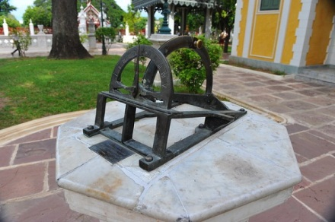

**Sundial** in front of the Ordination Hall of WatNiwetThammaprawat, Ayutthaya

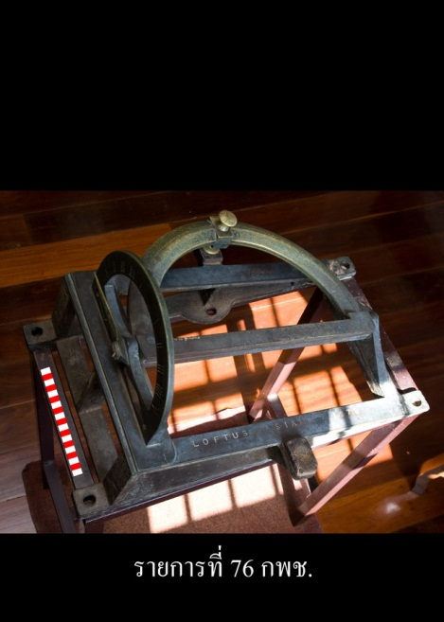

**Sundial,**Rattanakosin Period,SomdetPhraNarai National Museum